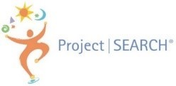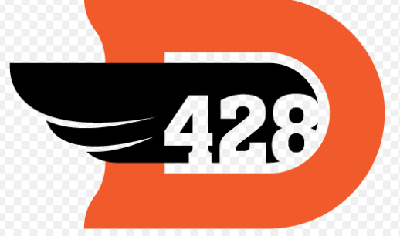

Project SEARCH Application 2024-2025
Thank you for your interest in Project SEARCH!
Before proceeding, please be aware that you must agree to the following terms set by Northwestern Medicine to be considered for Project SEARCH in DeKalb. As of the date of the release of this application, Northwestern Medicine is requiring interns to be fully vaccinated against Covid prior to the start of Project SEARCH. This does not include boosters, only the original vaccines. A flu shot is also required, but NM will provide this to interns who are accepted into the program in October if needed. Northwestern Medicine will not accept medical or religious exemptions for any unpaid positions, which includes Project SEARCH interns. These are policies set by Northwestern Medicine and they are non-negotiable.

Please read carefully before proceeding with the application:
- I understand that, if I’m accepted at Northwestern Medicine, I must meet the health screening requirements before starting Project SEARCH, complete a background check, get a flu shot, be up to date on all school required vaccines, and be fully vaccinated against COVID per Northwestern Medicine requirements for participating in the program at the Northwestern Medicine site. *Be aware that Covid policies could change.
*Please reach out to Lisa at 815-721-6359 or llynch@rampcil.org if you have questions.

Before proceeding, please also be aware that gaining employment is the goal for each graduate of Project SEARCH, but we do not plan for or guarantee that employment will be with Northwestern Medicine. Most graduates find community employment elsewhere.
Project SEARCH is a school-to-work transition program for young adults with disabilities that lasts for one (1) school year and includes post-graduation follow along services provided by RAMP. Project SEARCH serves young adults with disabilities that need an intensive year of career development, internship experience, and support to reach their employment goals. The program embraces interns that have a variety of disabilities (such as: physical and/or mental health disabilities) and challenges (such as: poverty and homelessness) as well.
Selection Priorities:
- Between the ages of 18-21
- Currently enrolled in high school with all necessary credits completed
- Have an IEP or 504
- Eligible for Vocational Rehab (VR) services through the Division of Rehab Services (DRS) **you may be required to provide documentation of your disability to your VR counselor once accepted into the program. If documentation cannot be obtained, your position in Project SEARCH will be at risk.
- Have a desire to gain competitive employment at the end of Project SEARCH
- Willing to use public transportation (if needed) to access work and the local community
There are 4 steps to the application process.
Step 1: You and your parent/guardian must complete this application (either paper or online version, not both). If filling out a paper form, please mail or email it to:
- Lisa Lynch, Project SEARCH Employment Specialist, at llynch@rampcil.org
- Attn: Project SEARCH
1 Kish Hospital Dr.
DeKalb, IL 60115
Step 2: The Project SEARCH Selection Team will:
- Review your application with consideration of your strengths, needs, and eligibility.
Step 3: If you are eligible to move forward, you must participate in our Project SEARCH Skills Assessment Day.
- Assessment Day is March 14th , 2024 during school hours at the Northwestern Medicine Kishwaukee Hospital Health & Wellness Center, 626 Bethany Rd, DeKalb IL 60115. Please put this date on your calendar. We will give you more details about this later.
Step 4: The selection team will:
- Review your Assessment Day results along with your application information.
- Complete a parent/guardian phone interview.

**Once these steps are complete, Northwestern Medicine will email all applicants with acceptance / declination letters.**

Project SEARCH Application Checklist

- Completed student application form

- Completed parent application form

- Completed parent/guardian phone interview (Onsite team will contact you after your application is submitted to set this up)

- Legal guardianship paperwork attached if applicable

**The below tasks must be completed by your school**

- Completed school personnel survey

- Sent the applicant’s current IEP or 504, including any transition plans and goals, and signed transfer of educational rights paperwork

- Sent the applicant’s attendance records
Project SEARCH Application
If interested, please watch this video about Project SEARCH: (Project SEARCH DeKalb Video - YouTube)
School Personnel Survey
Thank you for supporting your Project SEARCH applicant! Please take a few moments to respond to each question. The purpose of issuing this survey is to gain further insight into our applicants, to supplement information provided in the application, and to help guide discussion during the interview process. Your candid responses are invaluable and appreciated!
Additionally:
- We are grateful for your efforts to assist the applicant in obtaining a copy of his/her current or most recent IEP to include with the application packet.
- Program staff may call you for information about the applicant. Please include the best number to reach you.
- If you need any assistance or have any questions while filling this out, please reach out to llynch@rampcil.org, (815) 721-6359

Name of student you are referring to Project SEARCH:
School Personnel Name:
Title:
Email:
Phone number:
- Does the family/guardian/support person and the student both support competitive employment upon completion of Project SEARCH? (Please explain)

- Does the student need daily/continued support in any of the following areas: hygiene (including daily showering, hair brushing, body odor), toileting (including able to independently use the bathroom), and appearance (clean clothes, shaved, professional appearance).

- Is the student able to communicate efficiently his/her needs and wants in the classroom?

- Do you have any concerns about the student’s behavior? Is this student able to use coping strategies with or without assistance? (please explain)

- Do you have any concerns about the student’s physical ability, mobility, and stamina?

- Do you have any concerns about the student being able to complete tasks correctly and keep professional behavior, without direct supervision from staff?

- Is the applicant able to independently use Google applications or does the applicant/student need hand over hand/one-on-one help each time to successfully complete this?

- Please describe strengths that the applicant is likely to bring to the work environment.

- Please describe challenges that the applicant may experience in the work environment.

- Please describe the student’s ability to monitor and limit their technology use (video games, phone, tablets, etc.)? What strategies does the student use to ensure they are using technology appropriately.

Thank you for filling out this application!

